CMU-SE451 Capstone Project II
ARCHITECTURE DESIGN DOCUMENT
Version 1.0
Date:
Help Find Lost Loved Ones

Submitted by

Approved by
Thuan, Nguyen Tan Ph.D
Architecture Review Panel Representative:

Name Signature Date

Capstone Project 1- Mentor:

Name Signature Date
PROJECT INFORMATION
Project acronym | HFLLO
Project title | Help Find Lost Loved Ones
Start date | 28 Feb 2023 | End Date | 20 May 2023
Lead institution | International School, Duy Tan University
Project mentor | Thuan, Nguyen Tan Ph.D  Email: Thuannt.it.dtu@gmail  Phone: 0914 146 868

DOCUMENT NAME
Document Title | Architecture Design Document
Author(s) | C2SE.33
Role | Product Owner, Team Member, Scrum Master
Date | March 20, 2023 | File name: | [TMOS]Architecture Design-ver1.0.docx
URL

REVISION HISTORY
Version | Person(s) | Date | Description
1.0 | All Member | March 20, 2023 | Create Architecture Design Document

SIGNATURE
Document Approvals: The following signatures are required for approval of this document.
Mentor | Thuan, Nguyen Tan Ph.D | Signature:
Mentor | Thuan, Nguyen Tan Ph.D | Date:
 |  | Date:
Team Members

- Introduction
  - Purpose
This specification covers following:
- Brief specification of the project, high level requirement, system context for the system.
- Use case diagram, detail quality attribution.
- Architecture presented by various architecture view types: Component and Connect tor view, Module view, Allocation view.
  - Document Reference
Table 1: Document Reference

No | Reference
1 | ProductBacklog-and-User-story-C2SE.33-HFFLO
- Project Reference
  - Project Overview
- Project name: Help Find Lost Loved Ones
- Development team
Full name | Position
  - Business Driver

2.2.1. Business Problems
Currently, the number of children leaving home due to disagreements with their families is increasing rapidly. Additionally, the elderly often experience memory issues and may become lost and unable to find their way home. There are also individuals who were separated from their families during wartime and whose loved ones are still searching for them. To address these challenges, Help Find Lost Loved Ones was created. This website provides a platform to conduct searches based on key identifiers such as images and location data, allowing users to obtain the most accurate results possible.

2.2.2. Business Need
Customer need Help Find Lost Loved Ones can handle the following systems:
- The registrant will have to declare the correct information
- User searches for posts
- User can search by advanced image
- Connect relatives and friends with local supportive organizations and communities
- Users interact with posts

2.2.3. Project Goals
The site offers a comprehensive and effective solution to help those who are searching for a missing relative or friend. The main goal of the site is to provide tools and resources to help users easily find the information and contact the people they are looking for, and to connect them with organizations and support communities. local.

One of the key goals of this website is to enhance users' search and communication capabilities, by providing advanced search tools and features, and by establishing secure communication channels. and security between users and the people they are looking for. The website also aspires to bring full understanding and support to people in difficult situations, help them feel cared for and cared for, and avoid risks and dangers in the search process. sword.

3. Architecture Drivers

3.1. High-level Requirements
Refer to ProductBacklog-and-User-story-C2SE.33-HFLLO

3.2. System Context
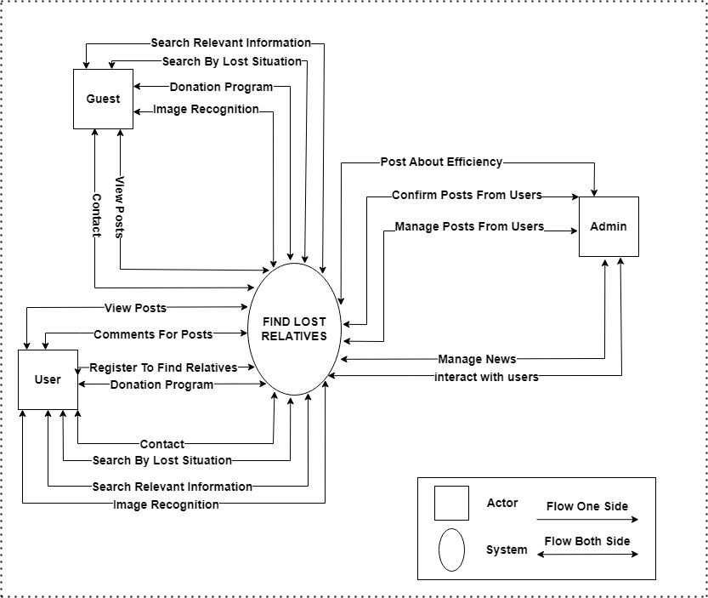
Figure 1. Context Diagram
- Admin is the most authorized person. Managers can manage user accounts, crud posts, tvshow and news, and manage search registration.

- User is the one who can view the posts on the system, search by many methods to filter out the desired results. They can interact with the posts and answer questions through the contact section.

- Guests are the lowest authority when they can only view posts, search as well as contact the admin.

3.3. Architecture Driver Specification

3.3.1. Use Case Entities
Table 2: Use case entities for admin
ID | E01
Title | User
Description | Admin uses the application
Identified Use Cases | UC01: Show post list  UC02: Show media video display  UC03: Show news list  UC04: Comment  UC05: Search post  UC06: Register to find relatives  UC07: Advanced search  UC08: Search by lost situation  UC09: Search for loved ones by pictures  UC10: Searching for loved ones by objects  UC11: Chat with admin  UC12: Chat by zalo  UC13: Search news

Table 3: Use case entities for user
ID | E02
Title | Admin
Description | Admin manage the application
Identified Use Cases | UC14: Show post list  UC15: Edit post  UC16: Delete post  UC17:View all posts registered to find relatives  UC18: Add new post  UC19: Show news list  UC20: Add new news  UC21: Edit news  UC22: Delete news  UC23: Show video media  UC24: Add video media  UC25: Edit video media  UC26: Delete video media  UC27: Edit Advanced search  UC28: Add the search information according to the lost situation  UC29: Edit the search information according to the lost situation  UC30: Restore photos to the past

3.3.2. Operational Use Case

No | Reference
1 | ProductBacklog-and-SprintBacklog-C2SE.33-HFLLO
2 | C2SE.33_Project-Plan

3.4. Quality Attributes
Table 4: Quality Attributes: Security
Quality Attributes | Security
Source(s) of Stimulus | User
Stimulus | Non
Relevant Environment  Conditions | Online
Architectural Elements | The system
System Response | Non
Response Measure(s) | Time/effort/resources required to circumvent security measures with success.
Description | In our system, the user is the one who can view the posts on the system, search by many methods to filter out the desired results. They can interact with the posts and answer questions through the contact section.

Table 5: Quality Attributes: Usability
Quality Attributes | Usability
Source(s) of Stimulus | First-time customer
Stimulus | Access
Relevant Environment  Conditions | Operation
Architectural Elements | The system
System Response | Provide introduction content on onboarding screen
Response Measure(s) | User satisfaction, gain of user’s knowledge.
Description | On the website, we will introduce information about the main function on the onboarding screen. So, users can more easily understand the website as a first-time customer.

4. Constraints

4.1. Business Constraint
- Project will be started on: February 28th, 2023.
- Project will be finished on: May 20th, 2023.
- Project will be finished in 79 days.

4.2. Technical Constraint
- Technology: JavaScript, Reacjs, NodeJs
- Environment:
- Operating System: Windows.
- Develop Tools: Visual Studio Code.
- Version Control System: Git.
- Database: MySql
- Internet Connection
5. High-level Architecture
5.1. Component and Connector View (C&C view)
The diagram below shows the overview architecture including components and other related components. We have representations and behaviors for important components in the following sections.
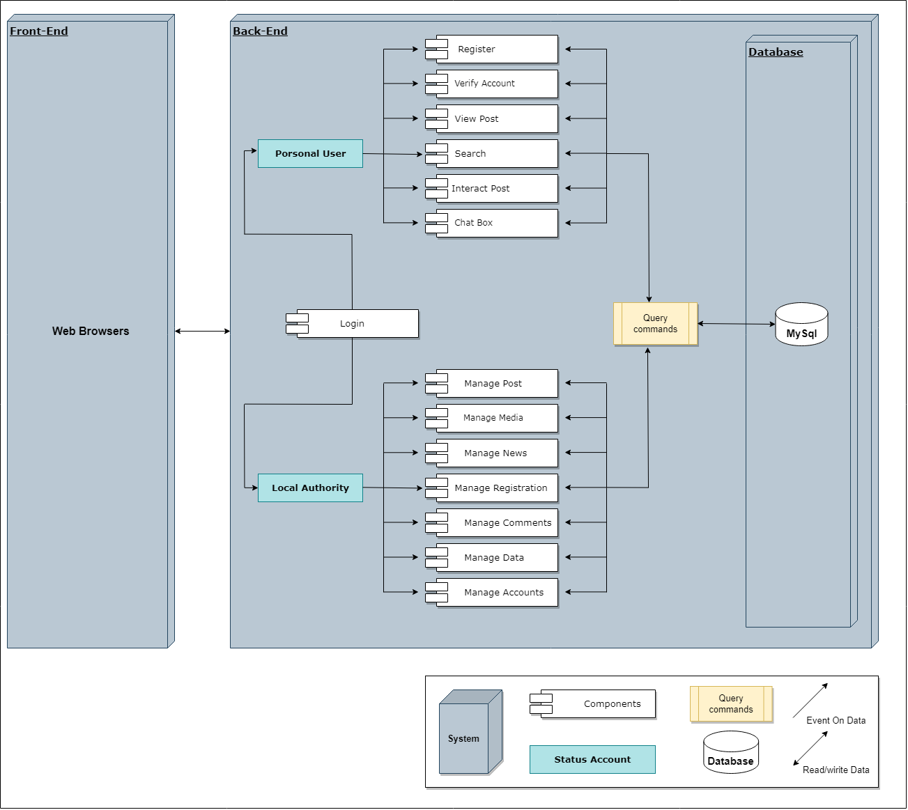
Figure 2. C&C View
Prose
Users will use the application and require an internet connection to access the system. One user accessed the system; the front-end interface will be displayed. With these frontend interfaces, user can go around the entire of the application. They can know which functions are on system easily. They will have a panoramic picture of some of the main functions of the system. From that, database from server can be transacted to users by MySql working. The application is authorized to access the database through data access.

5.2. Module View

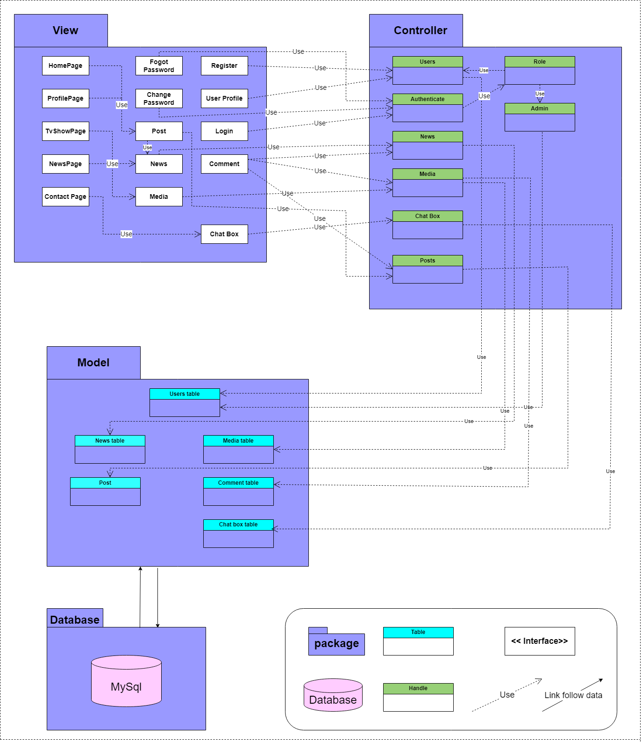

Figure 3. Module View

Prose
To process and authorize request from user, packages which responsibility for interacting with user, are tied up together to authorize the association between user and data. All user requests will be sent to and stored at the server through the application.
5.3. Allocation View
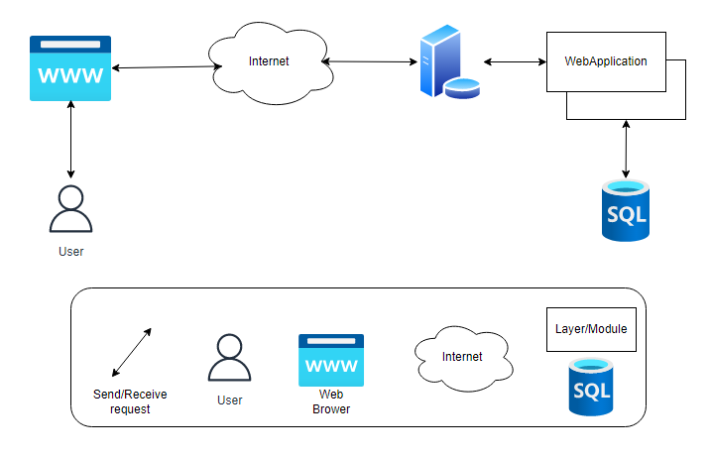
Figure 4. Allocation view

Prose
Users will use smart mobile phones or computers to be able to access the application. Once you have accessed the application, the application will be handled with a handle for database interaction between the user and the application. All transactions between the user and the system will be performed on SQL: MySql.

